Zach Tzavelis

ME465 - Sound and Space

02/07/2020

HW1: Introduction to Digital Signal Processing

**Question 1**

The purpose of question 1 was to implement a function that could perform both a Fast Fourier Transform (FFT) and inverse Fast Fourier Transform (IFFT) of a time domain signal. A 10 second 1 HZ sinusoidal wave was used for testing; To confirm the two functions were computing correctly, Parsevel’s theorem was computed after every transform to ensure it held true. See methods ‘my_fft’ and ‘my_ifft’ in the appendix code for implementation details. Furthermore, the results were analyzed graphically in Figures 1 and 2. Figure 2, which plots the magnitude of the complex numbers of the frequency spectrum, shows a symmetric response at -1 and 1 Hz as expected.

Figure 1: Time Domain Signals

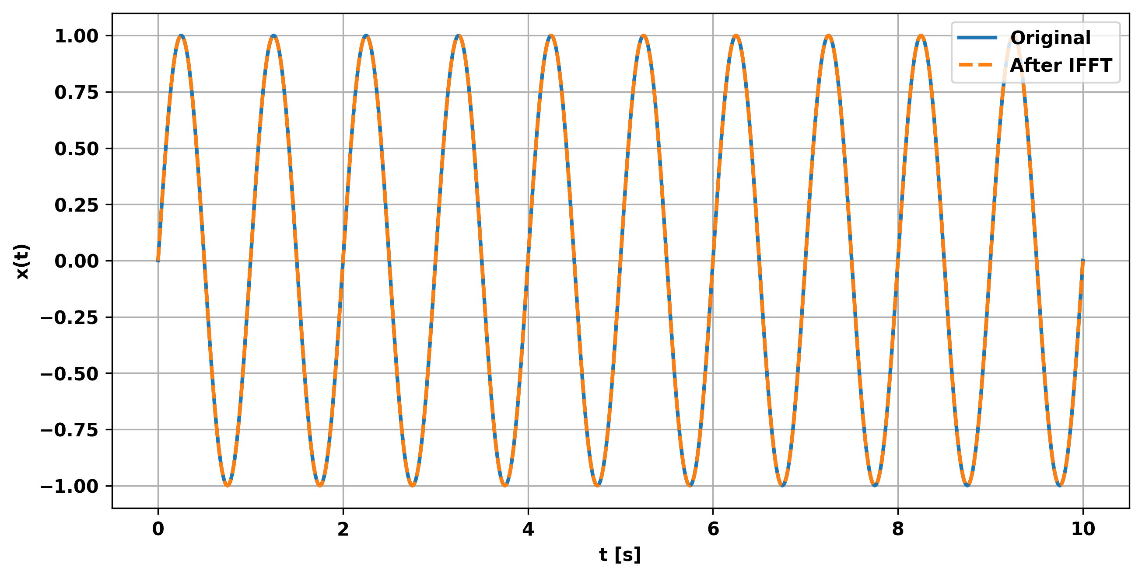

Figure 2: Frequency Domain Signal

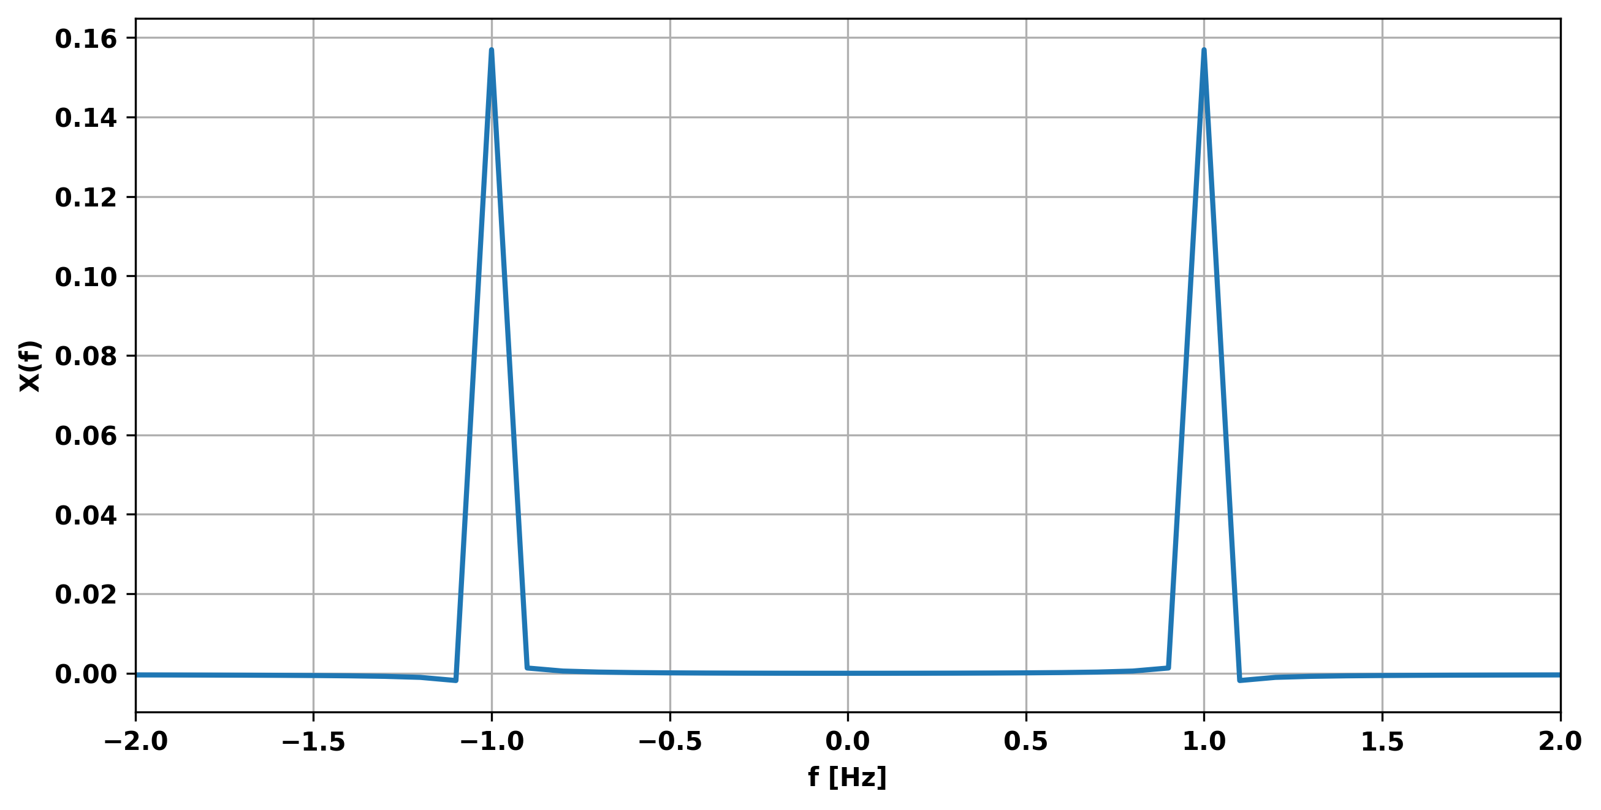

**Question 2**

Question 2 asked to analyze a signal of my own creation: I decided to analyze construction noise in the hopes that I can later design a signal to destructively interfere this kind of noise. Figure 3 shows the time domain signal, Figure 4 shows the frequency domain, and Figure 5 shows a snapshot of the phase as a function of frequency. Figure 4 shows that there are a wide range of frequencies present - the most prominent of which is at +/- 800 Hz.

Figure 3: Construction Noise Time Series

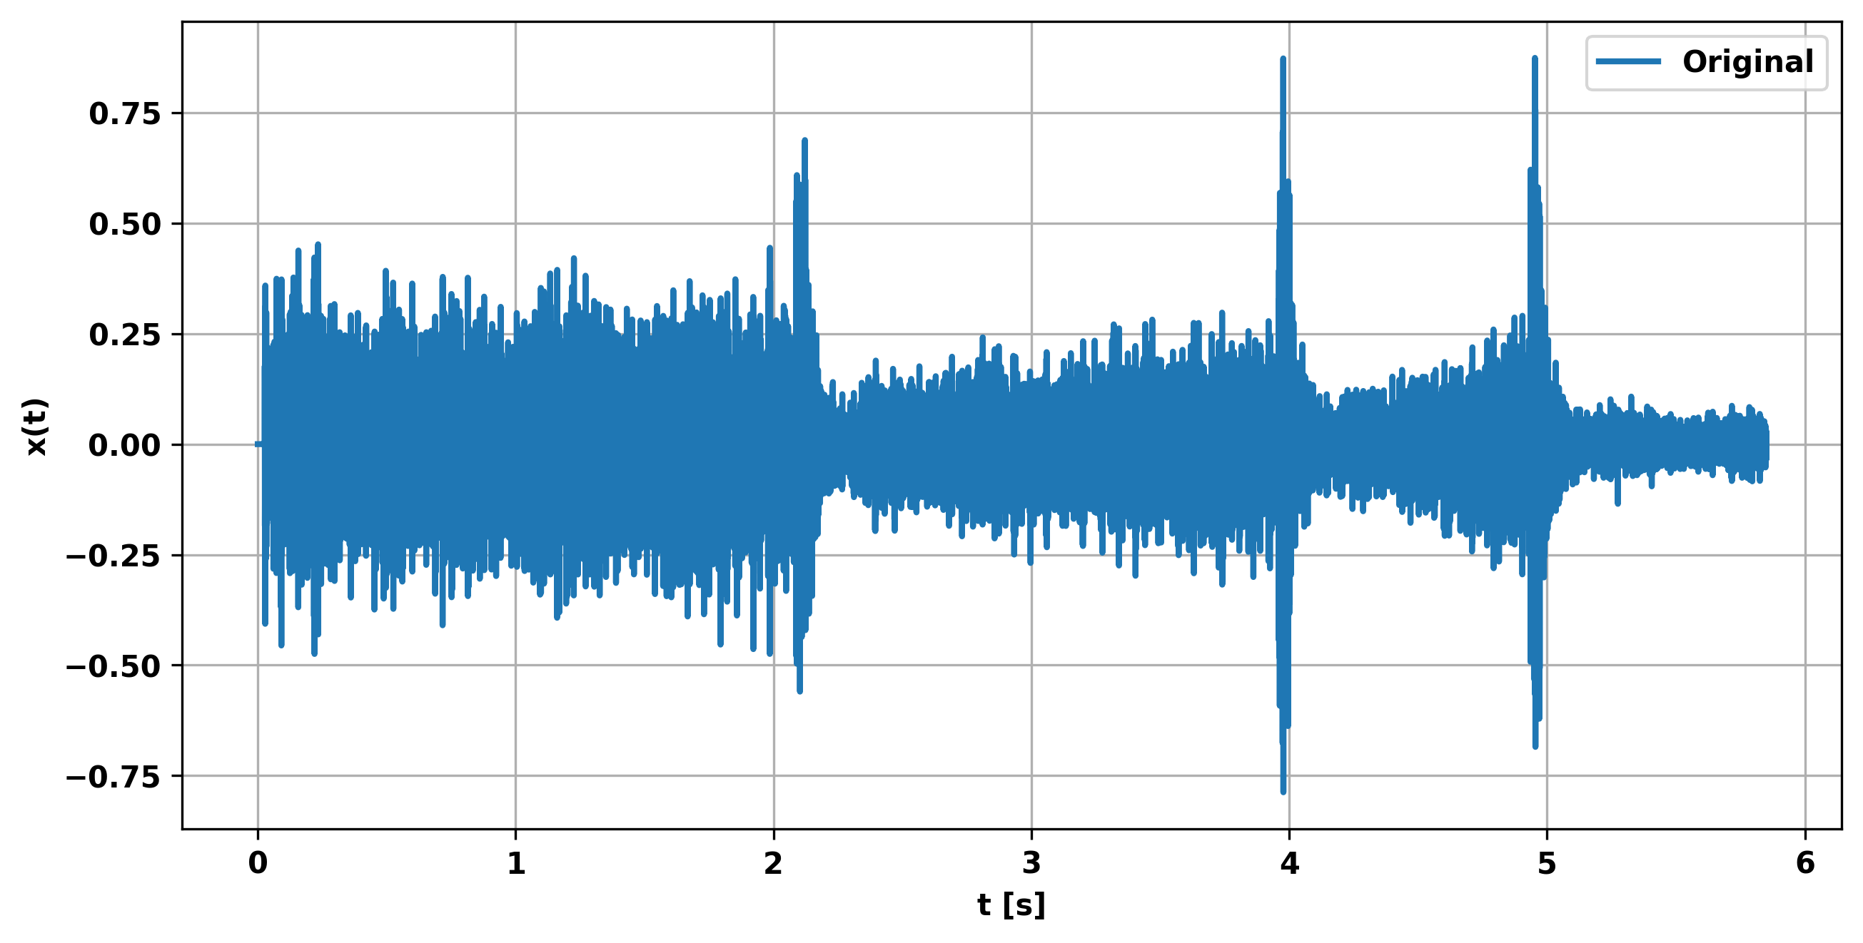

Figure 4: Construction Noise Frequency Domain

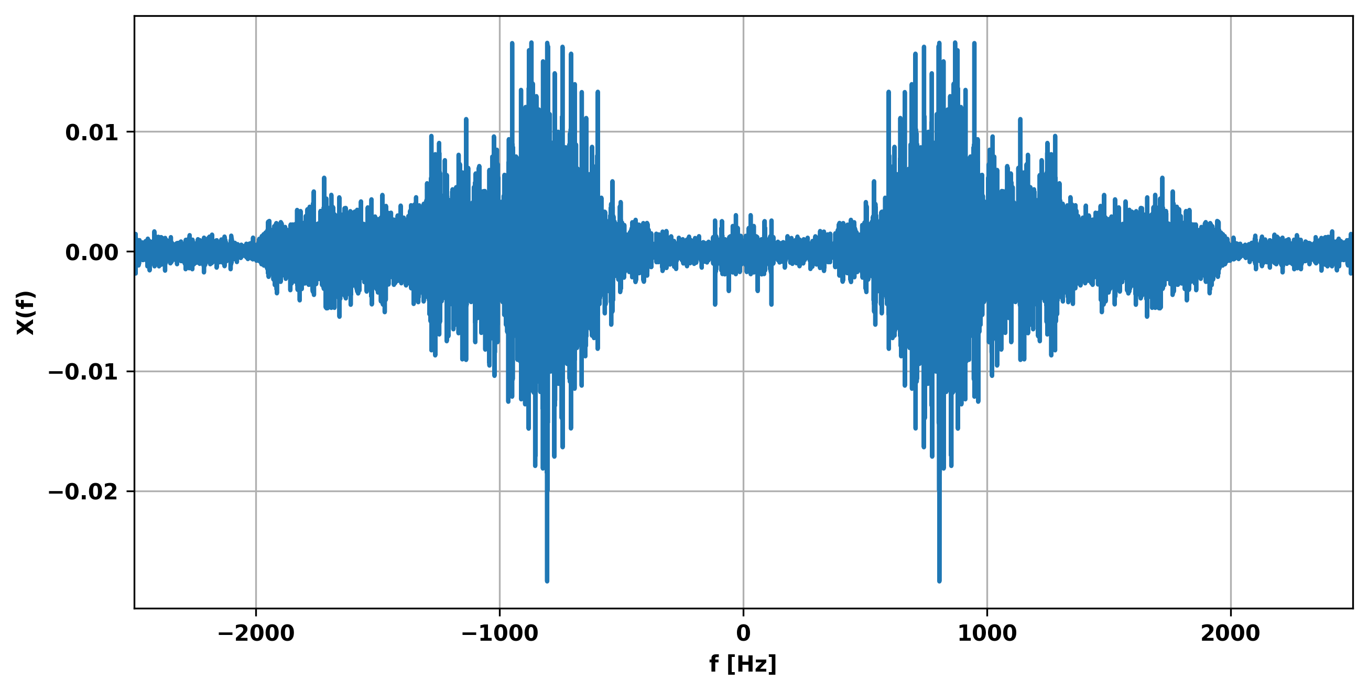

Figure 5: Construction Noise Phase

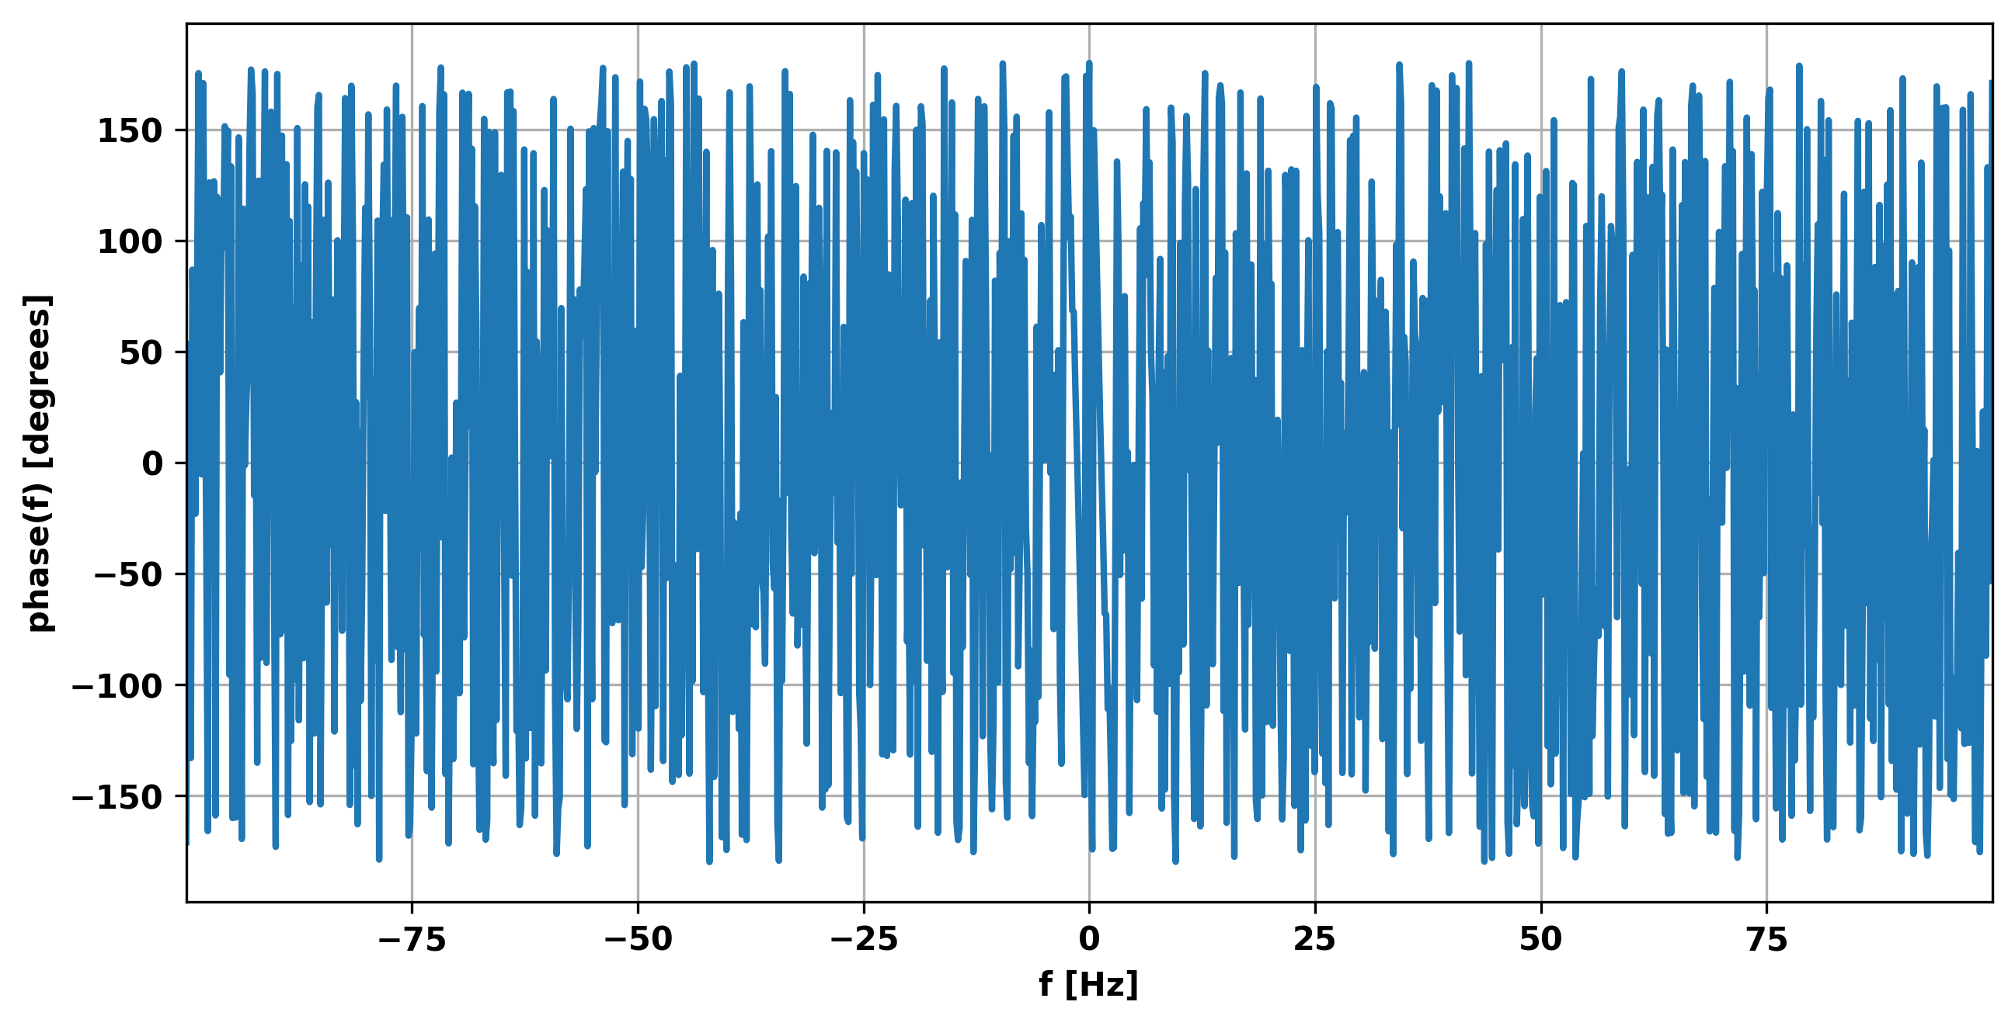

**Question 3**

b.) Question 3 instructed to analyze a recorder (musical instrument) melody provided in a .wav file. The seven second time domain signal is plotted in Figure 6 and its frequency response in Figure 7. Nine notes were played in the recording but it was difficult to determine if they were all unique by ear (associated with a different frequency). The frequency response shows 6 large peaks in the positive domain, with several smaller ones (probably harmonics of the first peaks) after 1000 Hz.

Figure 6: Time Domain Signal

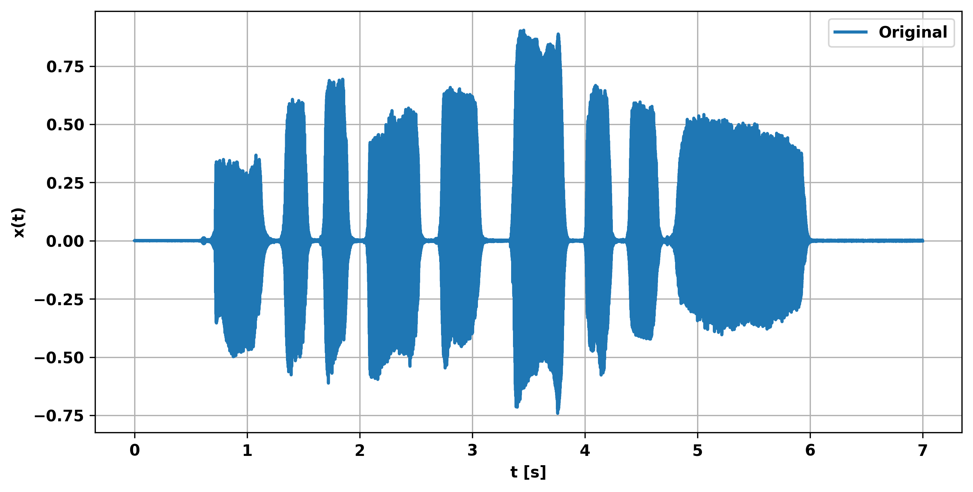

Figure 7: Frequency Domain Signal

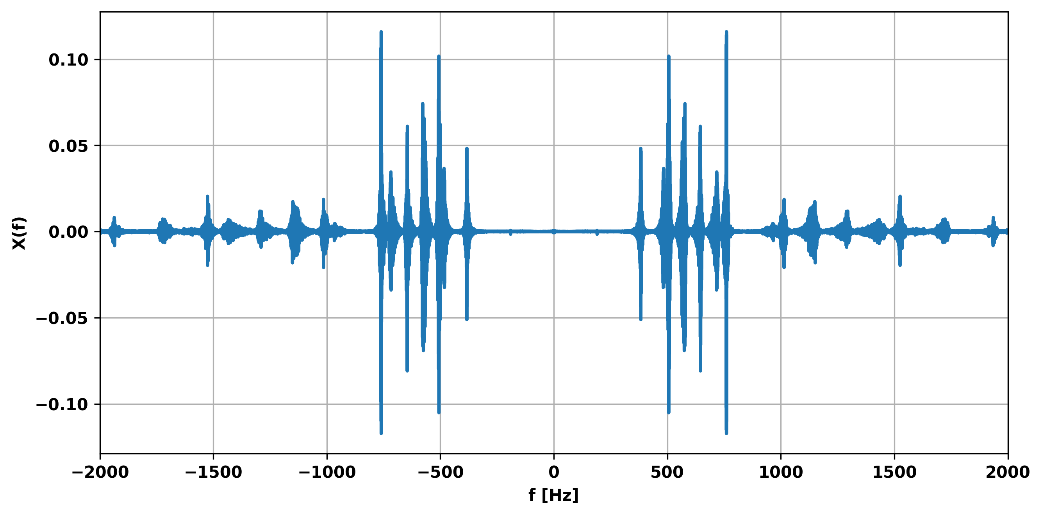

c.) Focusing our analysis on just a portion of the sound file during t=[2, 2.6], we see that there is a dominate frequency (largest amplitude) of 647 Hz (Figure 8). Note that the symmetric side of the spectrum isn’t depicted in order to provide a closer look at the area of interest.

Figure 8: Snapshot of Positive Frequency Domain of Input Signal during t=[2, 2.6]

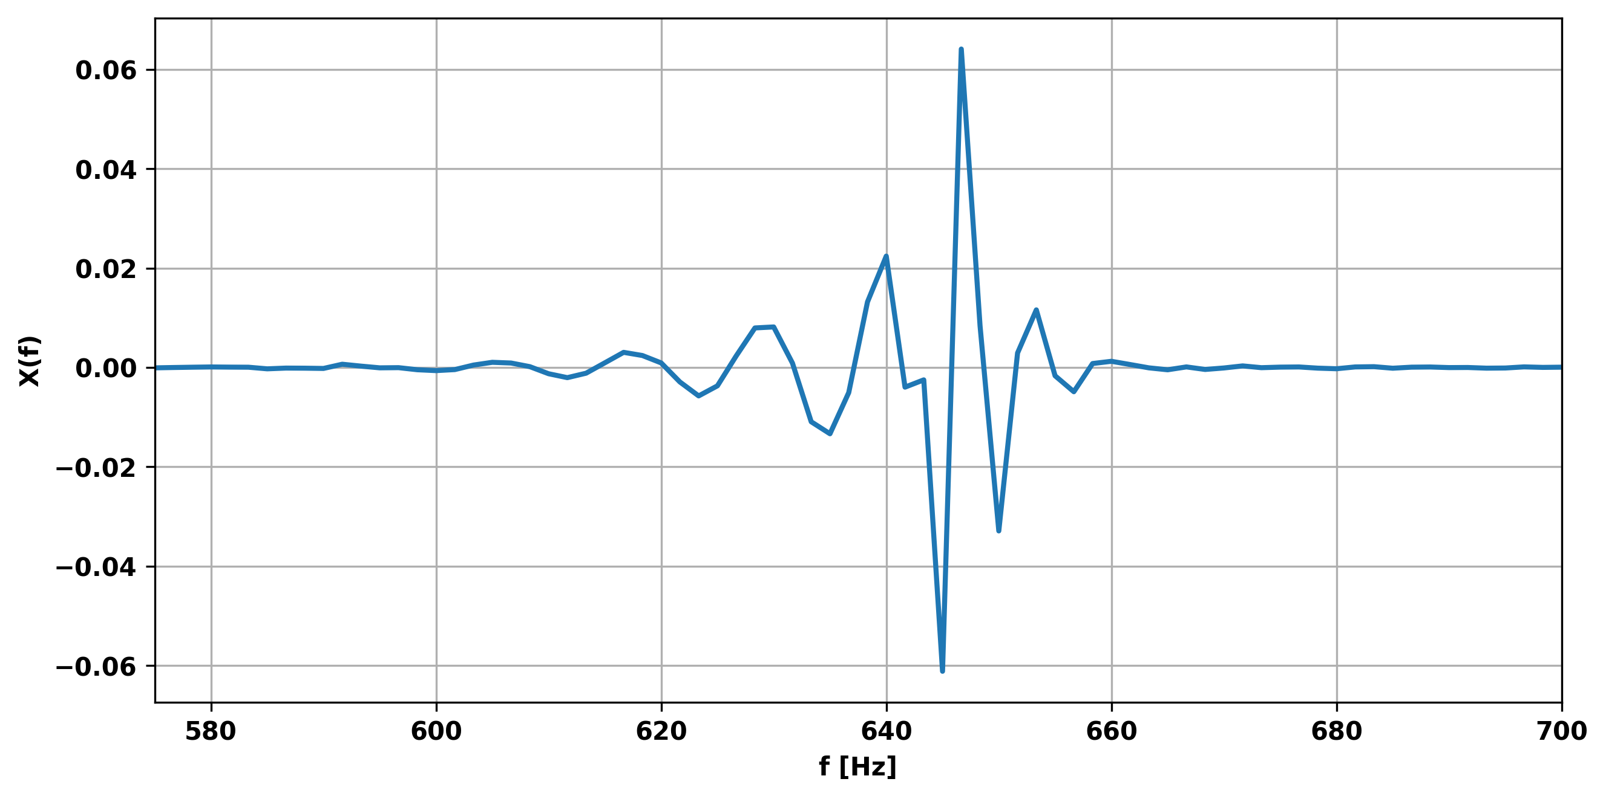

**Concluding Remarks**

For this homework I created a basic toolbox for analyzing digital signals. I created an FFT and IFFT functions which effectively transform signals between the time and frequency domains. The FFT function returns a symmetric frequency response, which indicates that the function performs frequency accounting correctly. The IFFT function returns precisely the original signal in Question 1, which indicates it too is likely working correctly. Furthermore, we saw that some signals we considered have fundamental frequencies with large amplitudes, and harmonics of those frequencies often occur with smaller amplitudes.